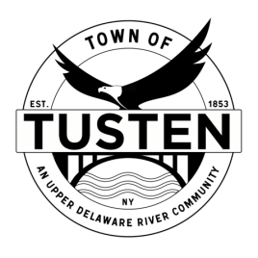
Public Hearing and Regular Meeting Agenda
March 28, 2023

PUBLIC HEARING 7:25 PM
Russell Miller, Big Eddy Brewery, 93 Main Street, Narrowsburg, NY~ SBL 10-1-19 for a special use permit

OPENING ITEMS ~

Call Meeting to Order at 7:30 PM

Pledge of allegiance

Minutes
- Accept Minutes from February 2023
- CORRESPONDENCE

OLD BUSINESS

Russell Miller, 93 Main Street, Narrowsburg, NY, SBL 10-1-19

NEW BUSINESS

Motion to set Public Hearing(s) for (if applicable):

CLOSING ITEMS

Board Comment

Meeting reminder

Adjournment

