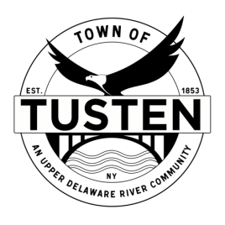
Regular Meeting Agenda
February 28, 2023

OPENING ITEMS ~

Call Meeting to Order at 7:30 PM

Pledge of allegiance

Minutes
- Accept Minutes from January 2023 and December 2022
- CORRESPONDENCE

OLD BUSINESS
Bobov Yeshiva Educational Center, 189 Blind Pond Road, Narrowsburg, NY SBL ~21-1-5.1, 21-1-1, 21-1-19.1

Russell Miller, 93 Main Street, Narrowsburg, NY

NEW BUSINESS

Motion to set Public Hearing(s) for (if applicable):

CLOSING ITEMS

Board Comment

Meeting reminder

Adjournment

