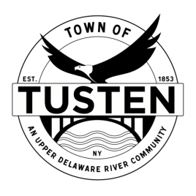
Regular Meeting Agenda
March 13, 2023
7:30 PM

OPENING ITEMS

Call Meeting to Order at 7:30PM

Pledge of allegiance

Minutes
- Accept Minutes from November 2022

OLD BUSINESS
NA

NEW BUSINESS
John Gleber Application, 23 Hankins Road, Narrowsburg, NY ~ SBL 23-1-2, 23-1-3.3

SET PUBLIC HEARING (S) ~ if applicable

Motion to set Public Hearing(s) for:

CLOSING ITEMS

Board Comment

Meeting reminder

Adjournment

